KITESURF IN GRADO

Active holidays

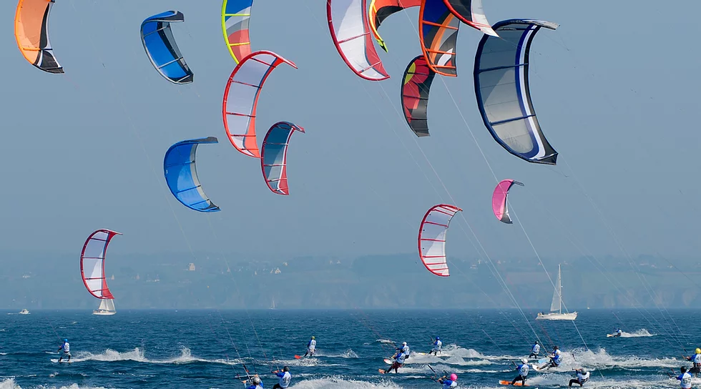

From 2 days to 1 week with accommodation in apartment or hotel + kitesurfing course

The Grado island and the Marina Julia beach are well known and appreciated not only by the Triveneto "raiders" but also by Slovenians, Austrians and Germans, as they are distinguished from the nearby Trivenete for their shallow sandy bottoms, which combined with a good winds create the ideal conditions for practicing this sport.

You can choose between different types of courses between basic or advanced courses.